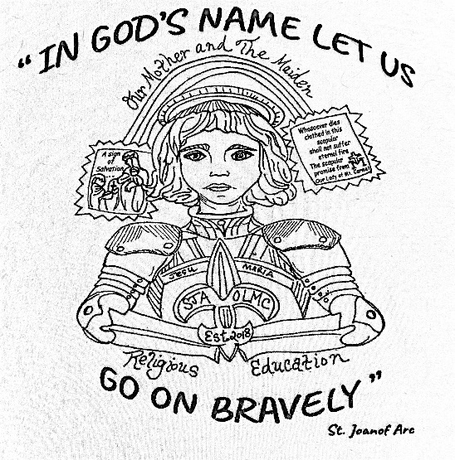
Student Registration Fees
2021-22
Registration Fees:
1 Child - 175.00
2 Children - $225.00
3+ Children - $275.00

Sacramental Fees:
Reconciliation - $10.00
Communion - $50.00
Confirmation – $100.00

Participation Fees:
Per Family (Annual) - $10.00

